Epitaph Monster and Trial guide

Notes :

* As of 3.2 update JT has become very easy, there are no point in doing JT in epi anymore.
* WIP.
* Its best to look for JT monster in the world outside, only do this when you know what you are doing.
* Not for newbie, IR>90 recommend, need strong party, pawns, experience with epitaph.
* The point is kill what monster you need to JT, avoid completing the trial, only cancel/failed it so you can repeat instantly.
* Include Crest reward from trial.
* A good place to find monster location for JT : dd-on-rookies.com and h1g.jp/dd-on/
* Owner: Nn Stan (RiF).

# Season 3.0

### First Section : Shrine **Lvl 83- All paid trial cost 10 souls**

#### Main road monster:

Ghost 7

Undead 2

Sword undead 3

Skeleton brute 1

Skeleton warrior 3

Skeleton 2

Skeleton sorcerer 3

Skeleton warrior 2

Ghost mail 1

#### **Main road Trial:**

* First Trial:

Condition: Clear all mobs/ Do not take any Abnormality status.

Monster:

Ghoul 1

Undead 4

Stout undead 3

Note:

* Second Trial:

Condition: Clear all mobs/ Do not use item/ Do not die.

Monster:

Gorechimera 1

Skeleton brute 2

Note:

* Third Trial:

Condition: Kill more than 20 mobs/ Time limit 1’20.

Monster:

Empress ghost 1

Skeleton brute 2

Ooze 6

Note: Any mobs killed will respawn shortly after, good spot to farm pawn’s EXP. Very easy to cancel/repeat.

* Fourth Trial:

Condition: Kill more than 20 mobs/Do not take any Abnormality status/ Time limit 2’.

Monster:

Medusa 1

Gargoyle 4

Skeleton sorcerer 4

Note: Any mobs killed will respawn shortly after, easy to cancel/repeat.

#### **First area monster: Gold chest here**

Skeleton warrior 2

Frost skeleton 7

Frost skeleton brute 2

Freezing slime 3

Frost corpse torturer 1

Wyrm 1

Wight 2

Frost corpse punisher 2

Skeleton sorcerer 1

Skeleton mage 1

#### **First area Trial:**

* Free version:

Condition: Clear all mobs/ Time limit 1’/ Do not take Abnormality status more than 3 times.

Monster:

Living armor 1

Frost corpse torturer 2

Frost skeleton 2

* Paid version:

Reward: Crest of Fortitude+ (Healing power+7). Only listed the best possible reward crest (low drop chance)

Condition: Clear all mobs / Time limit 3’ / Do not die.

Monster:

Frost machina 1

Frost corpse punisher 2

Frost skeleton brute 2

#### **Second area monster:**

Stout undead 10

Flame corpse toturer 4

Skeleton mage 2

Flame corpse punisher 2

Skull lord 1

Note: Some monsters only appear when you enter the small room with 2 chests.

#### Second area Trial:

* Free version:

Condition: Clear all mobs/ Do not use item/ Do not die.

Monster:

Geo golem 1

Skull lord 2

* Paid version:

Reward: Crest of flesh cutting IV (Demihuman slayer 16).

Condition: Clear all mobs/ Do not die/ Time limit 6’ .

Monster:

Drake 1

Witch 2

#### Third area monster:

Lux skeleton 9

Mist warrior 2

Mist sorcerer 3

Lux skeleton brute 1

Mist fighter 3

Mist hunter 3

Angule 1

#### Third area Trial:

* Free version:

Condition: Clear all mob/ Do not die/ Time limit 2’.

Monster:

White chimera 1

Eliminator slay 2

* Paid version:

Reward: Crest of burning+/ Crest of flame warding+( Inflict catching fire 26/ Fire resist 14)

Condition: Kill more than 20 mobs/ Do not use item /Time limit 2’.

Monster:

White griffin 1

Lux skeleton 4

Siren 2

Note: Any mobs killed will respawn shortly after.

#### Fourth area Monster: Gold chest here

Shadow harpy 6

Dark skeleton brute 1

Dark corpse punisher 3

Empress ghost 2

Black griffin 1

#### Fourth area Trial:

* Free version:

Condition: Clear all mob/ Do not die/ Do not take Abnormality status more than 3 times

Monster:

Shadow chimera 1

Shadow harpy 2

* Paid version:

Reward: Crest of Sealing/ Crest of Stifle Warding+ (Inflict skill stifling 20/ Resist skill stifling 20)

Condition: Clear all mob/ Do not die/ Do not take Abnormality status more than 3 times

Monster:

Nightmare 1

Death knight 2

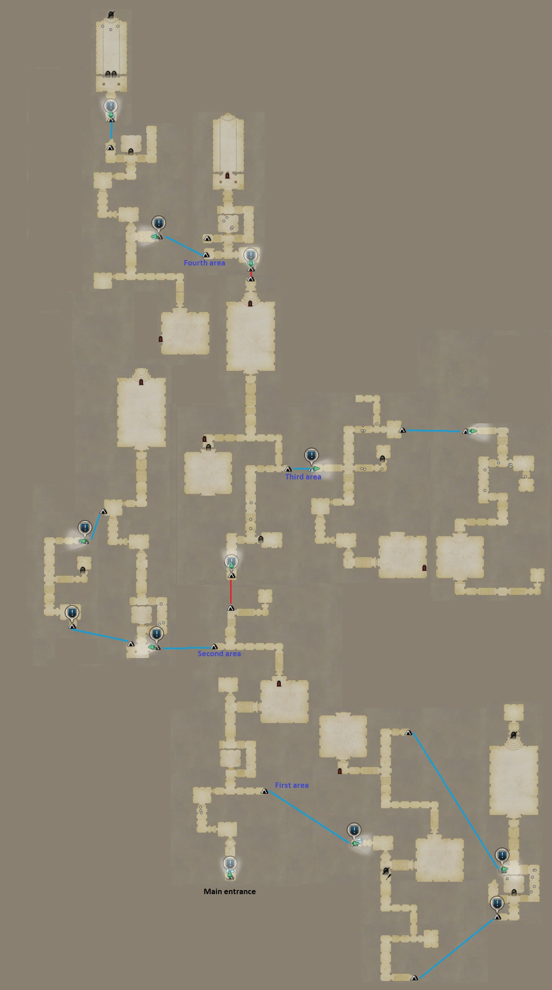

### Second Section: Cave **Lvl 83- All paid trial cost 20 souls**

#### Main road monster:

Wolf 11

Siren 4

Grim goblin 2

Little crag 6

#### Main road Trial:

* First trial:

Condition: Clear all mob/ Kill at least 2 mobs with an Abnormality status active on them.

Monster:

Green guardian 8 (?)

Ent 1

* Second trial:

Condition: Clear all mob/ Do not die.

Monster:

Cragger 1

Little crag 4

* Third trial:

Condition: Clear all mob/ Do not die/ Kill at least 3 mobs with an Abnormality status active on them.

Monster:

Cockatrice 1

Grimwarg 8 (?)

#### First area monster: Gold chest here

Grim goblin 4

Sling grim goblin 3

Grim goblin fighter 10

Goblin shaman 3

Grim goblin leader 2

Goblin aid shaman 1

#### First area Trial:

* Free version:

Condition: Kill more than 20 mobs/ Do not die/ Kill at least 3 mobs with an Abnormality status active on them.

Monster:

Orge 1 (?)

Grim goblin fighter 6 (?)

Note: Any mobs killed will respawn shortly after.

* Paid version:

Reward: Crest of unburdening (weapon -15% weight, armor -20% weight)

Condition: Kill more than 20 mobs/ Do not die/ Kill at least 3 mobs with an Abnormality status active on them.

Monster:

Gore cyclop 1 (?)

Goblin shaman 3

Goblin aid shaman 3

Note: Any mobs killed will respawn shortly after.

#### Second area monster:

Sulfur saurian 9

Goblin shaman 3

Rock saurian 3

Siren 3

Silver roar 1

#### Second area Trial:

* Free version:

Condition: Kill more than 20 mobs/Do not die/ Kill at least 5 mobs with an Abnormality status active on them (?)

Monster:

Sulfur saurian 4

Giant sulfur saurian 1

Saurian sage 3

Note: Any mobs killed will respawn shortly after.

* Paid version:

Reward: Crest of beast hunting IV ( Beast slayer 16)

Condition: Kill more than 20 mobs/Do not die/ Kill at least 5 mobs with an Abnormality status active on them (?)

Monster:

Gorechimera 1

Sulfur saurian 4

Note: Any mobs killed will respawn shortly after.

#### Third area monster:

Little crag 2

Rock saurian 3

Saurian sage 4

#### Third area Trial:

* Free version:

Condition: Clear all mob/ Do not use item/ Time limit 2’.

Monster:

White chimera 1

Brute ape 4

* Paid version:

Reward: Crest of Deep sleep/ Crest of Sleep warding+ ( Inflict Sleep 15/ Resist Sleep 20)

Condition: Clear all mob/ Do not die/ Do not use item.

Monster:

Behemoth 1

Rock saurian 4

#### Fourth area monster: Gold chest here

Brute ape 12

Grimwarg 2

Wolf 3

#### Fourth area Trial:

* Free version:

Condition: Clear all mob/ Inflict Abnormality status 2 times/ Time limit 3’

Monster:

Troll 1

Strix 5

* Paid version:

Reward: Crest of freezing+/ Crest of ice warding+ ( Inflict Frozen solid 20/ Ice resist 14)

Condition: Clear all mob/ Inflict Abnormality status 2 times/ Do not die.

Monster:

Black griffin 1

Little crag 5

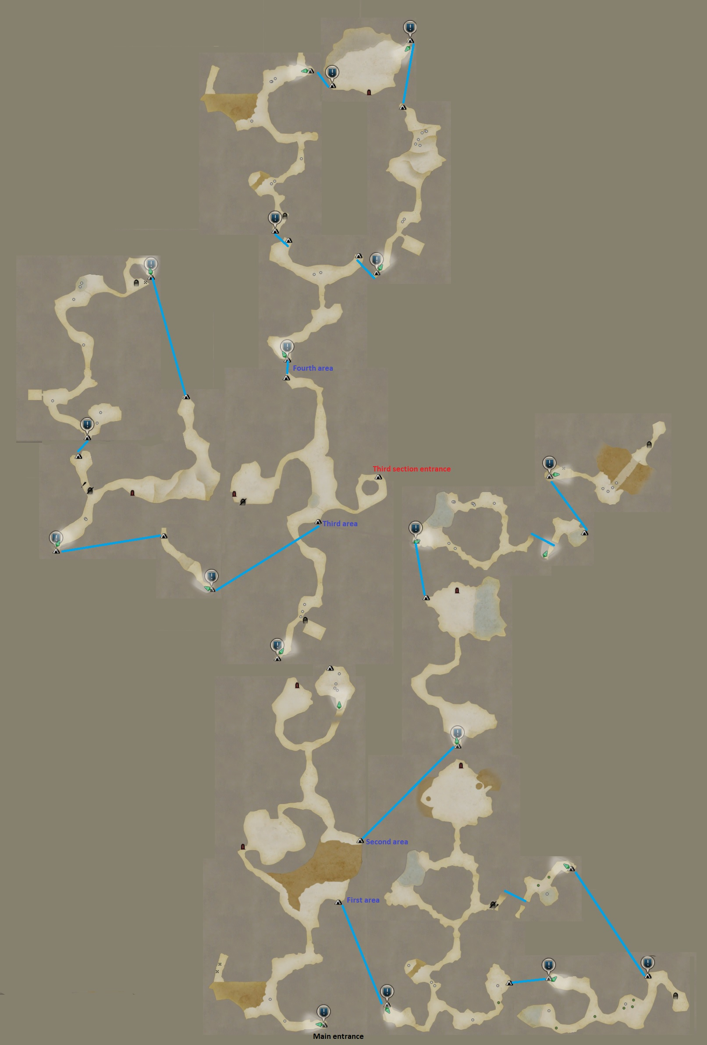

### Third Section: Cave depth Lvl84- All paid trial cost 30 souls

#### Main road monster:

Saurian 6

Saurian sage 3

#### Main road Trial:

* First trial:

Condition: Clear all mob/ Time limit 50”.

Monster:

Little crag 6

* Second trial:

Condition: Clear all mob/ Time limit 5’.

Monster:

Saurian sage 4

Angule 1

* Third trial:

Condition: Clear all mob/ Do not die.

Monster:

Troll 1

Mole troll 1

#### First area monster: Gold chest here

Strix 3

Grim goblin fighter 3

Grim goblin 3

Goblin shaman 2

Goblin aid shaman 3

Grimwarg 2

Brute ape 2

#### First area Trial:

* Free version:

Condition: Clear all mob/ Do not take Abnormality status 3 time/ Time limit 2’.

Monster:

Freezing slime 8

Wight 1

* Paid version:

Reward: Crest of Greater Intelligence+ (Magick defense 7)

Condition: Kill more than 15 mobs/ Do not take Abnormality status 3 time/ Time limit 2’.

Monster:

Large Newt 1

Blue newt 4

Note: Any mobs killed will respawn shortly after.

#### Second area monster:

Pyro slime 4

Mudman 5

Freezing slime 2

Sludgeman 2

#### Second area Trial:

* Free version:

Condition: Clear all mob/ Do not take Abnormality status 3 time/Do not die.

Monster:

Mudman 8

Golem 1

* Paid version:

Reward: Crest of Demon Slaying IV ( Ogre slayer 16)

Condition: Clear all mob/ Do not take Abnormality status 3 time/Do not use item.

Monster:

Geo golem 1

Sludgeman 8

#### Third area monster:

Wolf 2

Grimwarg 4

Green guardian 5

Brute ape 2

Strix 8

#### Third area Trial:

* Free version:

Condition: Clear all mob/ Do not use item/ Time limit 5’.

Monster:

Black griffin 1

Strix 4

* Paid version:

Reward: Crest of Diminished Fire resist/ Crest of burn warding+/ Crest of Decreased fire resist prevention (Inflict Fire resist down 22/ Resist catching fire 20/ Resist fire resist down 34)

Condition: Time limit 5’ (?)

Monster:

White griffin 1

Siren 4

#### Fourth area monster: Gold chest here

Giant sulfur saurian 2

Saurian sage 3

Little crag 3

Sulfur saurian 3

Cragger 1

#### Fourth area Trial:

* Free version:

Condition: Destroy all part/ Time limit 3’.

Monster:

Manticore 1

* Paid version:

Reward: Crest of Fragility/ Crest of Frail warding+ (Inflict Frail 20/ Resist Frail 25).

Condition: Destroy all part/ Do not take Abnormality status 3 time.

Monster:

Lindwurm 1

### 

### 

### Fourth Section: Waterway Lvl85- All paid Trial cost 40 souls

#### Main road monster:

Sword soldier dwarf orc 3

Grim goblin fighter 3

Acid blob 2

Goblin shaman 2

Heavy solder dwarf orc 4

Squad leader dwarf orc 1

Sling grim goblin 2

War ready grimwarg 6

Goblin aid shaman 2

Blunt soldier dwarf orc 2

Grim goblin fighter 1

#### Main road Trial:

* First trial:

Condition: Clear all mob/ Inflict Abnormality status 3 times.

Monster:

Blunt soldier dwarf orc 4

Ranged soldier dwarf orc 2

Squad leader dwarf orc 1

* Second trial:

Condition: clear all mob/ Destroy all part.

Monster:

Colossus 1

Sword soldier dwarf orc 2

* Third trial:

Condition: Clear all mob/ Destroy all part/ Inflict Abnormality status 5 times.

Monster:

War ready gore cyclop 1

War ready grimwarg 4

* Fourth trial:

Condition:

Monster:

#### First area monster: Gold chest here

Deep slime 6

Sword soldier dwarf orc 2

Ranged soldier dwarf orc 3

Grim goblin 5

War ready grimwarg 2

#### First area Trial:

* Free version:

Condition: Clear all mob/ Do not die/ Inflict Abnormality status 3 times.

Monster:

Ranged soldier dwarf orc 4

Sword soldier dwarf orc 2

Blunt soldier dwarf orc 1

* Paid version:

Reward: Crest of Greater Magick+ (Magick attack 9)

Condition: Clear all mob/ Inflict Abnormality status 3 times/ Kill at least 3 mobs with an Abnormality status active on them (???)

Monster:

Ranged soldier dwarf orc 4

War ready grimwarg 2

Squad leader dwarf orc 1

#### Second area monster:

Skeleton warrior 6

Skeleton mage 2

Ghost mail 1

Skeleton sorcerer 4

Dark corpse torturer 3

Dark corpse punisher 2

Skeleton knight 4

Skeleton brute 1

#### Second area Trial:

* Free version:

Condition: Clear all mob/ Do not die/ Time limit 2’.

Monster:

Eliminator 4

Eliminator slay 2

* Paid version:

Reward: Crest of Diminished Ice resist/ Crest of Freeze warding+/ Crest of Decreased Ice resist Prevention( Inflict Ice resist down 22/ Resist Frozen solid 20/ Resist Ice resist down 34)

Condition: Clear all mob/ Do not die/ Time limit 3’ (?)

Monster:

Frost machina 1

#### Third area monster:

Shadow goblin 2

Shadow sling goblin 2

Shadow wolf 2

Shadow harpy 2

Death knight 1

Ghost mail 2

Shadow chimera 1

#### Third area Trial:

* Free version:

Condition: Clear all mob/ Do not take Abnormality status 3 times.

Monster:

Shadow wolf 3

Shadow sling goblin 2

Shadow chimera 1

* Paid version:

Reward: Crest of Crystallization/ Crest of Petrification Warding (Inflict Petrification 15/ Resist Petrification 17)

Condition: Clear all mob/ Do not take Abnormality status 3 times.

Monster:

War ready goremanticore 1

War ready grimwarg 5

#### Fourth area monster: Gold chest here

Mist fighter 3

Mist warrior 6

Mist sorcerer 2

#### Fourth area Trial:

* Free version:

Condition: Kill more than 15 mobs/ Time limit 2’/ Do not die.

Monster:

Mist hunter 2

Mist warrior 2

Empress ghost 1

Note: Any mobs killed will respawn shortly after.

* Paid version:

Reward: Crest of Giant Killing IV (Giant slayer 16)

Condition: Kill more than 20 mobs/ Do not die/ Time limit 2’.

Monster:

Mist hunter 2

Mist fighter 2

Mist Wyrm 1

Note: Any mobs killed will respawn shortly after.

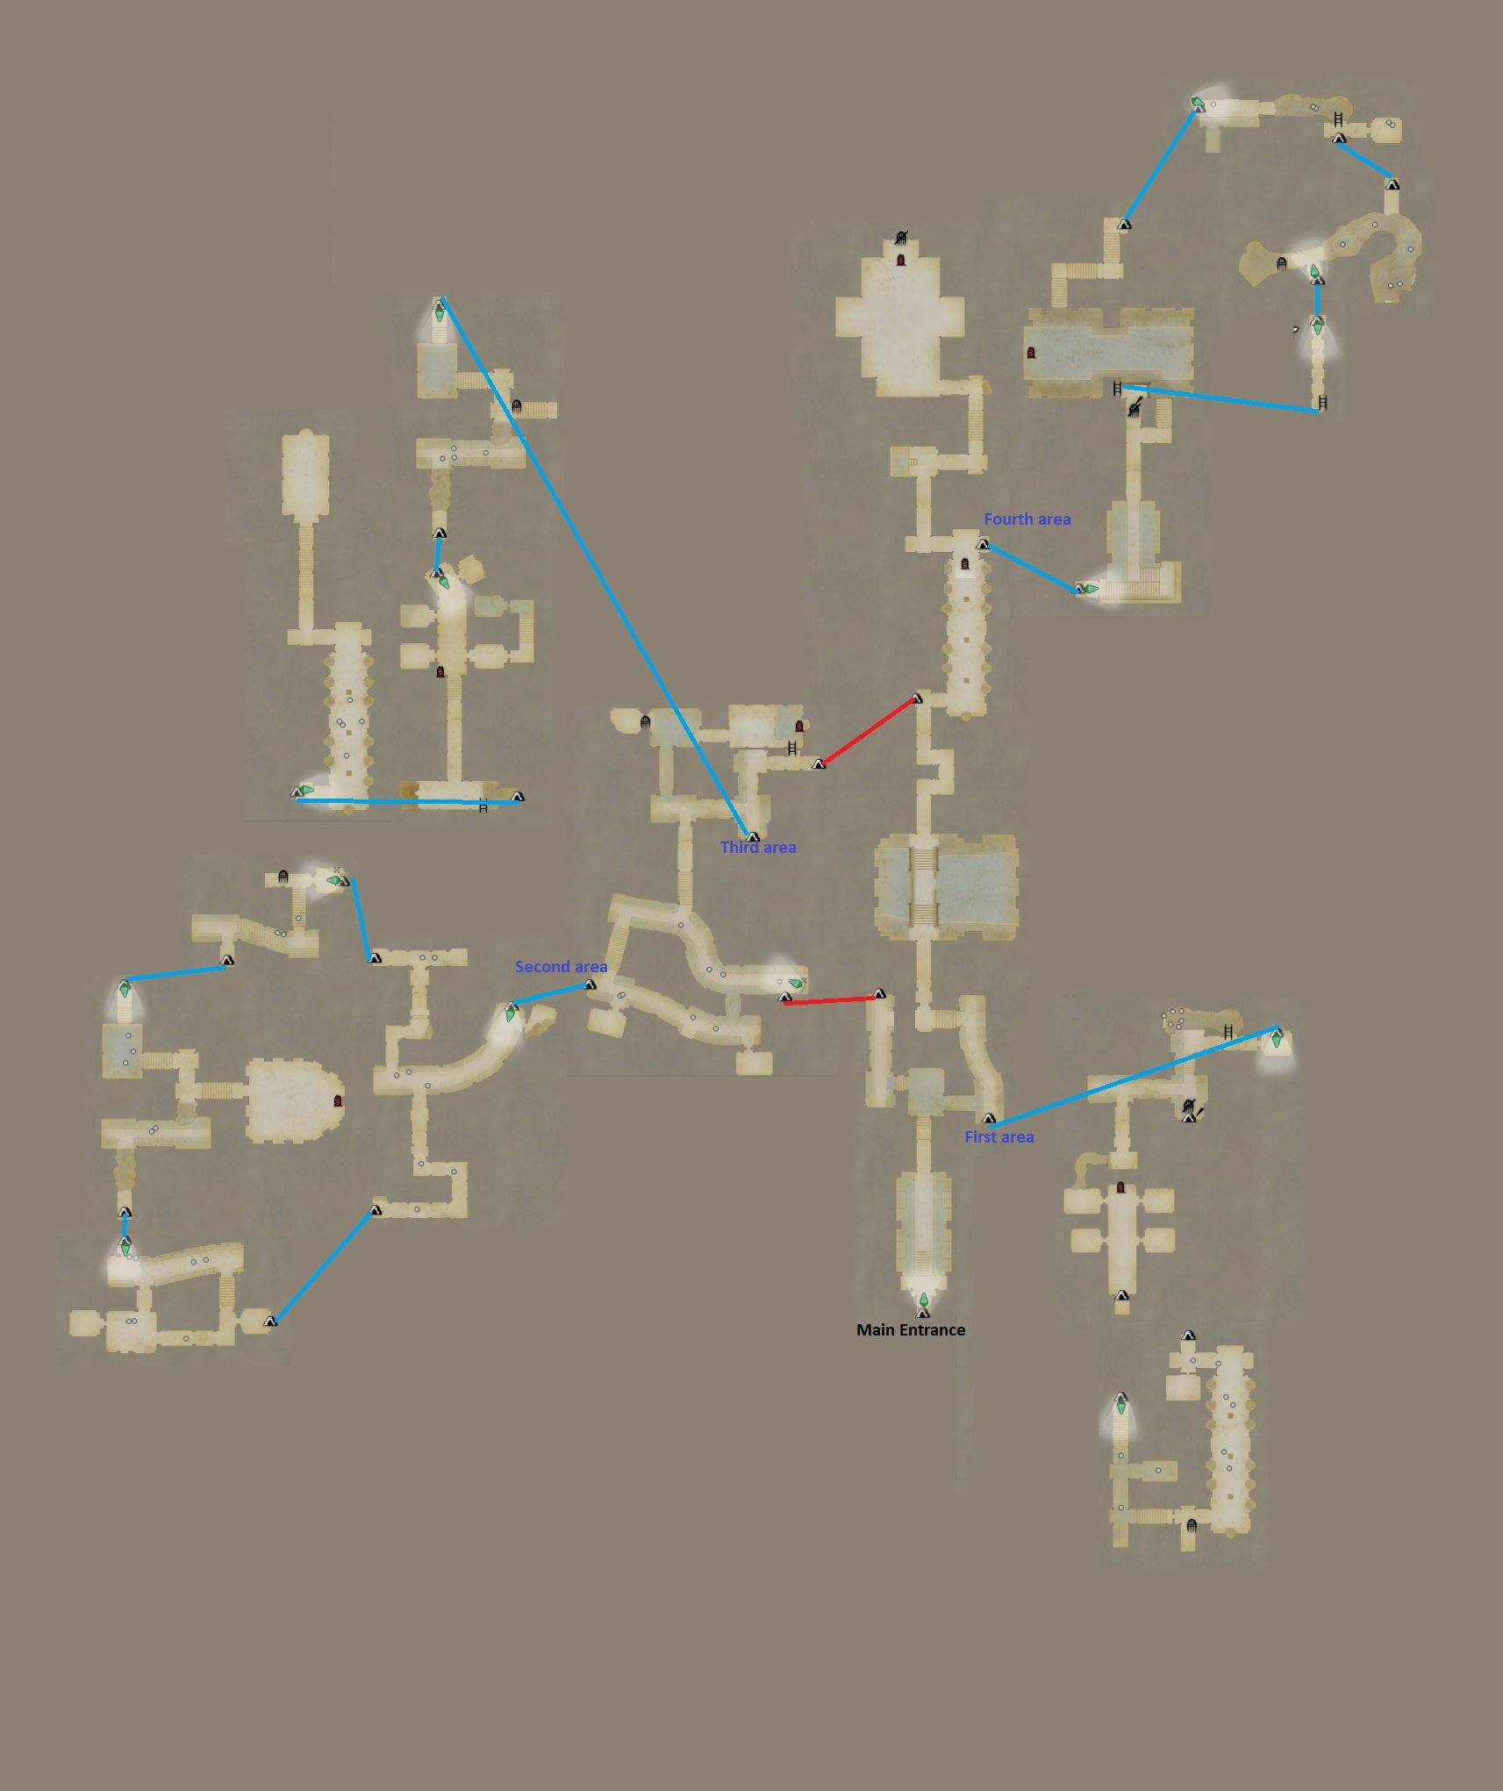

# Season 3.1

### First Section: Ruin Monster Lvl 88 - All paid trial cost 10 souls

#### Main road monster:

Undead 5

Grim goblin leader 3

Grimwarg 2

Skeleton mage 4

Greater goblin 1

Grigori 2

Stout undead 4

Skeleton sorcerer 2

Skeleton warg 2

Ghost mail 4

#### Main road Trial:

* First trial:

Condition: Clear all mob/ Do not take Abnormality status 3 times.

Monster:

Death knight 1

Grim goblin fighter 4

* Second trial:

Condition: Time limit/ Do not die.

Monster:

Eliminator 2

Grigori 1

Beared grigori 1

* Third trial:

Condition: Do not die/ Do not take any Abnormality status.

Monster:

Gore manticore 1

Eliminator slay 2

#### First area monster: Gold chest here

Misery ghost 7

Eliminator 1

Skeleton warrior 1

Skeleton knight 1

#### First area Trial:

* Free version:

Condition: Clear all mob/ Do not use item/ Do not take Abnormality status 3 times.

Monster:

Frost corpse punisher 4

Living armor 1

* Paid version:

Reward: Crest of Exorcism ( Cursed slayer 16)

Condition: Time limit/ Do not use item/ Do not take Abnormality status 3 times.

Monster:

Witch 1

Skull lord 2

#### Second area monster:

Sword undead 3

Undead 3

Grim goblin leader 1

Greater goblin 6

Stout undead 3

Flame corpse torturer 2

Flame corpse punisher 2

Skeleton warg 4

Goblin aid shaman 2

#### Second area Trial:

* Free version:

Condition: Do not use item/ Do not die

Monster:

Colossus 1

Greater goblin 2

Goblin shaman 2

* Paid version:

Reward: Crest of Fracturing ( Skeleton slayer 16)

Condition: Do not die/ Do not take Abnormality status 3 times.

Monster:

Gore chimera 1

Grim goblin leader 1

#### Third area monster:

Skeleton warg 8

Gargoyle 4

Bolt grimwarg 1

Frost skeleton 2

Skeleton sorcerer 3

Skeleton warrior 3

#### Third area Trial:

* Free version:

Condition: Time limit/ Do not take Abnormality status 3 times.

Monster:

Wight 1

Frost skeleton brute 4

* Paid version:

Reward: Crest of Shock +/ Crest of lighting warding (Inflict shock 26/ Thunder resist 14)

Condition: Do not take any Abnormality status/ Destroy all part

Monster:

Skeleton cyclop 1

Skeleton mage 4

#### Fourth area monster: Gold chest here

Grim goblin leader 2

Little crag 2

Eliminator 4

#### Fourth area Trial:

* Free version:

Condition: Do not use item/ Do not die.

Monster:

Ghoul 1

Cragger 1

* Paid version:

Reward: Crest of Drowning / Crest of Drench warding (Inflict drenching 20/ Resist drenching 34)

Condition: Do not die/ Time limit

Monster:

Witch 1

Wight 1

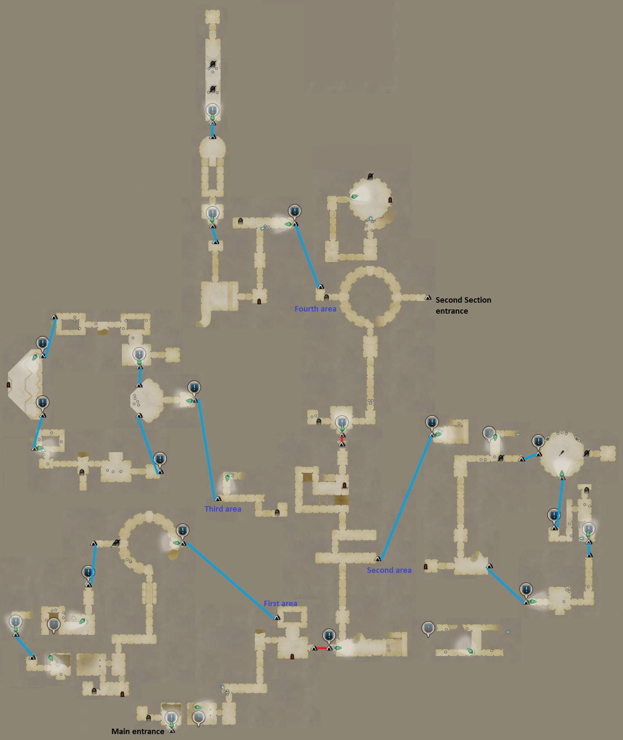

#### 

### Second Section: Well Monster Lvl88- All paid trial cost 20 souls

#### Main road monster:

Little crag 3

War ready ogre 1

Ranged soldier dwarf orc 1

War ready saurian 3

Blunt soldier dwarf orc 4

War ready giant saurian 1

#### Main road Trial:

* First trial:

Condition: Clear all mob/ Time limit

Monster:

Ranged soldier dwarf orc 2

Little crag 2

War ready grimwarg 2

* Second trial:

Condition: Kill at least 5 mobs with an Abnormality status active on them.

Monster:

Ranged soldier dwarf orc 3

War ready saurian 5

War ready giant saurian 1

Note: more can spawn after killed some.

* Third trial:

Condition: Time limit/ Kill at least 3 mobs with an Abnormality status active on them.

Monster:

War ready Goremanticore 1

Greater goblin 2

Sling grim goblin 3

Note: more can spawn after killed some.

#### First area monster: Gold chest here

Ranged soldier dwarf orc 1

Heavy soldier dwarf orc 4

War ready Grimwarg 4

#### First area Trial:

* Free version:

Condition: Do not use item/ Time limit.

Monster:

Ghoul 2

* Paid version:

Reward: Crest of Stubborn Perseverance ( Endurance 12)

Condition: Time limit/ Do not use item.

Monster:

War ready ogre 1

#### Second area monster:

War ready saurian 2

Brute ape 3

Ranged soildier dwarf orc 5

Heavy soldier dwarf orc 4

Squad leader dwarf orc 2

#### Second area Trial:

* Free version:

Condition: Time limit/ Do not use item.

Monster:

War ready giant saurian 1

War ready grimwarg 4

* Paid version:

Reward: Crest of Greater Tarring/ Crest of Tar Warding (Inflict Tarring 20/ Resist Tarring 34)

Condition: Time limit/ Do not use item.

Monster:

War ready ogre 1

Brute ape 4

#### Third area monster:

War ready saurian 6

War ready grimwarg 7

Squad leader dwarf orc 1

#### Third area Trial:

* Free version:

Condition: Do not die/ Kill at least 3 mobs with an Abnormality status active on them.

Monster:

War ready goremanticore 1

War ready saurian 2

War ready grimwarg 2

* Paid version:

Reward: Crest of Massacre IV ( Undead slayer 16)

Condition: Do not die/ Kill at least 3 mobs with an Abnormality status active on them.

Monster:

War ready gorecyclop 1

Ranged soldier dwarf orc 2

#### Fourth area monster: Gold chest here

War ready saurian 2

Lindwurm 1

#### Fourth area Trial:

* Free version:

Condition: Time limit/ Do not die.

Monster:

War ready grimwarg 4

War ready saurian 4

War ready giant saurian 1

* Paid version:

Reward: Crest of Diminished Lighting Resist/ Crest of Shock Warding/ Cres of Decreased Thunder Resist Prevention ( Inflict Thunder Resist down 22/ Resist shock 17/ Resist Thunder resist down 34)

Condition: Time limit/ Do not die.

Monster:

War ready Goremanticore 1

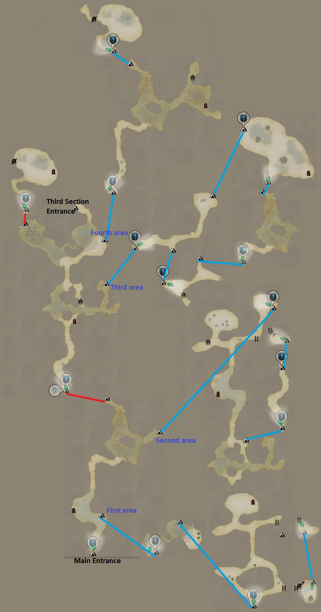

#### 

### Third Section: Tombs Monster Lvl89- All paid trial cost 30 souls

#### Main road monster:

Frost skeleton 3

Flame skeleton 3

Gargoyle 6

Undead 8

Stout undead 7

Skeleton warg 18

Skeleton warrior 3

Skeleton knight 3

Skeleton mage 2

Living armor 1

Skull lord 2

Brute ape 7

Dark skeleton 3

Grimwarg 3

#### Main road Trial:

* First trial:

Condition: Do not take any Abnormality status 3 times.

Monster:

Skull lord 2

Living armor 3

* Second trial:

Condition: Do not use item.

Monster:

Goremanticore 1

* Third trial:

Condition: Do not die/ Do not use item.

Monster:

Skeleton cyclop 1

War ready ogre 2

#### First area monster: Gold chest here

Gigant machina 1

Skull lord 4

Gargoyle 4

Note: Only appear if you appoarch the lever.

#### First area Trial:

* Free version:

Condition: Do not use any item/ Do not take any Abnormality status 3 times.

Monster:

Nightmare 1

Living armor 2

* Paid version:

Reward: Crest of Greater Protection ( Physical defense 7)

Condition: Do not use any item/ Do not take any Abnormality status 3 times.

Monster:

White Chimera 1

Death knight 2

#### Second area monster:

Witch 1

Undead 6

Ghost mail 2

#### Second area Trial:

* Free version:

Condition: Do not die/ Do not use item.

Monster:

Chimera 1

Gorechimera 1

* Paid version:

Reward: Crest of Purification IV ( Spirit slayer 16)

Condition: Do not die/ Do not take any Abnormality status 3 times.

Monster:

Gigant machina 1

Frost machina 1

#### Third area monster:

Gargoyle 4

Eliminator 9

Eliminator slay 2

#### Third area Trial:

* Free version:

Condition: Time limit/ Do not die/ Kill 15 mobs.

Monster:

Skeleton mage 6

Empress ghost 1

* Paid version:

Reward: Crest of Dwindled defense/ Crest of Lowered defense prevention (Inflict Physical def down 30/ Resist Physical def down 25)

Condition: Time limit/ Do not die/ Do not use item/ Kill 15 mobs.

Monster:

Shadow harpy 6

Medusa 1

#### Fourth area monster: Gold chest here

Ghoul 1

Grimwarg 4

Wight 2

Lux corpse punisher 3

Dark corpse torturer 3

Lux skeleton brute 2

Skeleton warg 9

#### Fourth area Trial:

* Free version:

Condition: Do not die/ Inflict Abnormality status 3 times.

Monster:

Drake 1

Angule 1

* Paid version:

Reward: Crest of torpor/ Crest of torpor warding ( Inflict torpor 10/ Resist torpor 20)

Condition: Do not die/ Inflict Abnormality status 3 times.

Monster:

Manticore 1

Goremanticore 1

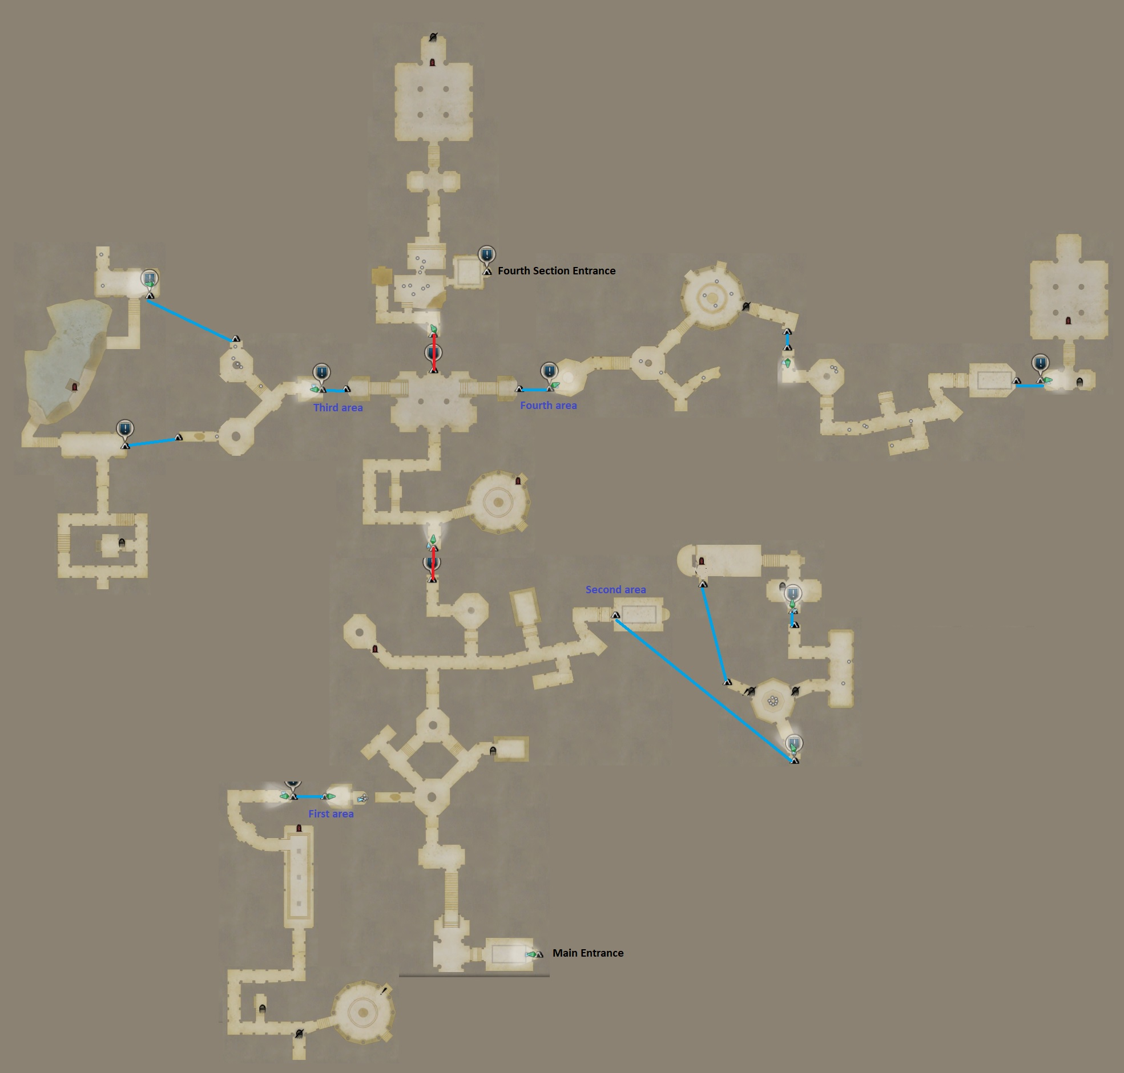

### Fourth Section: Deep ruins Monster Lvl90- All paid trial cost 40 souls

#### Main road monster:

Shadow goblin fighter 8

Shadow sling goblin 2

Mist hunter 1

Mist sorcerer 1

Shadow wolf 2

Mist fighter 3

Shadow goblin leader 2

#### Main road Trial:

* First trial:

Condition: Do not use item.

Monster:

Shadow Chimera 1

* Second trial:

Condition: Time limit.

Monster:

Shadow harpy 4

Shadow goblin fighter 3

Shadow goblin leader 1

* Third trial:

Condition: Time limit/ Do not use item

Monster:

Empress ghost 1

Skeleton cyclop 2

#### First area monster: Gold chest here

Shadow goblin fighter 2

Shadow wolf 2

Shadow harpy 4

Shadow sling goblin 2

White chimera 1

#### First area Trial:

* Free version:

Condition: Time limit/ Do not take any Abnormality status 3 times.

Monster:

Living armor 2

Aqua jelly 5

* Paid version:

Reward: Crest of Greater power+ ( Physical attack 9)

Condition: Time limit/ Do not take any Abnormality status 3 times.

Monster:

Death knight 2

Shadow harpy 5

#### Second area monster:

Ghost 4

Mist warrior 4

#### Second area Trial:

* Free version:

Condition: Do not use item/ Do not die.

Monster:

Mist drake 1

* Paid version:

Reward: Crest of Expulsion ( Demon slayer 16)

Condition: Do not die/ Do not take any Abnormality status 2 times.

Monster:

Mist Wyrm 1

Mist warrior 3

#### Third area monster:

Shadow goblin fighter 3

Shadow goblin leader 6

Shadow sling goblin 2

Shadow goblin 3

Shadow wolf 3

Shadow harpy 4

#### Third area Trial:

* Free version:

Condition: Time limit/ Kill 15 mobs/ Do not take any Abnormality status.

Monster:

Shadow goblin leader 1

Shadow sling goblin 8

Note: any monster killed will respawn shortly after.

* Paid version:

Reward: Crest of Dwindled Magick+/ Crest of Lowered magick prevention ( Inflict Magick atk down 30/ Resist Magick atk down 25)

Condition: Time limit/ Kill 15 mobs/ Do not take any Abnormality status 3 times.

Monster:

Death knight 1

Shadow chimera 1

Shadow sling goblin 8

Note: any monster killed will respawn shortly after.

#### Fourth area monster: Gold chest here

Mist warrior 3

Mist sorcerer 3

Mist hunter 2

#### Fourth area Trial:

* Free version:

Condition: Time limite/ Do not die.

Monster:

Geo golem 1

* Paid version:

Reward: Crest of Curse warding ( Resist curse 15)

Condition: Time limit/ Do not take any Abnormality status 3 times.

Monster:

Gigant machina 1

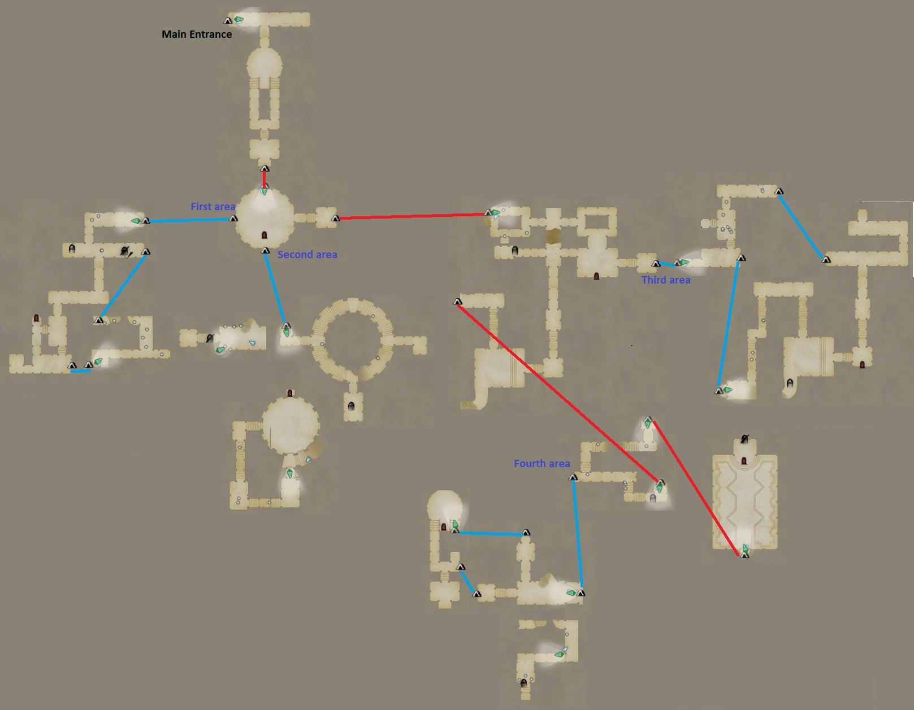

Place holder for next SS 3.2 epi

# Season 3.2

There are some changes to the new epi system, old epi will remain as they are:

* There are no longer side area and spirit wall to break, no statues to touch either, you finish the PQ and unlock HO tree by beating the Big trial.
* All trial is in the same area.
* There are small trials which need to be unlock by spending soul before you can attempt to challenge them.
* Once you unlock all small trial in a section you can challenge the Big trial in that section ( Just spend 20 souls to unlock them, you dont need to challenge them).
* There are no green door or gold chest, you get the reward by beating the Big trial, reward will be reset at every 5:00 Monday JST.
* Upon beating any trials you can choose a temporary buffs, up to 6 can be active at a time, once you leave the epitaph the effect will end. There are buffs that boost trial clear reward/ field mobs drop (Buffs table listed below).

As of now you can unlock the new EX (T) version by beating First section Big trial.

The next sections will be unlock at : 5/24 and 5/31.

### First section: Memory of Megadosys (5/2) Monster lvl93 / All paid Trial cost 10 souls

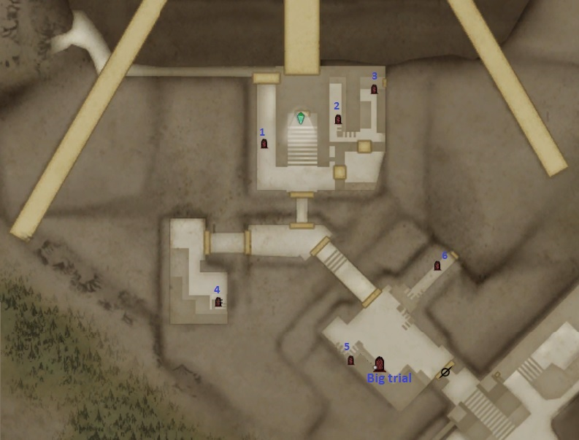

**Big trial Reward**:

Weekly first clear reward (random):

* Bone pearl.
* IR110 Body clothing 4*.
* IR105 clothing 0-4*.
* Memento Fiber 100 pieces (Fixed).
* 13 Executor’s soul.
* 40 HO.

Repeatable reward:

* 6 Executor’s soul.
* 40 HO.
* ~~3 Memento Fiber (random).~~ Removed after 5/31

**Small trials reward**:

Free version:

* 11 Executor’s soul.
* 40 HO.
* 3 Memento Fiber (random).

Paid version:

* 1 Crest (random listed below, only listed highest tier it can drop).
* 80 HO.
* 3 Memento Fiber (Fixed).

**Monster:**

Megado guard 18

Mist Priest 7

Mist sorcerer 6

Mist warrior 2

Shadow harpy 3

Shadow wolf 4

Mist fighter 3

Mist Hunter 2

Dim Slime 3

#### Big Trial:

Condition: Kill the wyrm/ Do not die/ Do not use item.

Monster:

Mist Wyrm 1

Megado guard (warrior) 4 ( will keep spawning until you kill the wyrm)

Megado guard (sorcerer) 4 ( will keep spawning until you kill the wyrm)

#### Trial 1:

* Free version:

Condition: Time limit 1’30/ Do not use item/ Clear all mob.

Monster:

Megado guard 7 ( hunter and fighter).

* Paid version:

Reward: Crest of Flesh cutting (Demihuman slayer 16)

Crest of Manslaying (Human slayer 16)

Condition: Time limit 2’/ Do not use item/ Clear all mob.

Monster:

Megado guard (warrior) 4

Mist Priest 3

#### Trial 2:

* Free version:

Condition: Time limit 2’/ Do not use item/ Clear all mob.

Monster:

Shadow harpy 3

Shadow wolf 3

Megado guard (warrior) 3

* Paid version:

Reward: Crest of Sealing ( Inflict Skill Stifling 20)

Crest of Dwindled defense ( Inflict Physical def down 30)

Crest of Stifle warding ( Resist Skill stifling 20)

Crest of Lowered defense prevention ( Resist Physical def down 25)

Condition: Time limit 3’/ Do not take status debuffs 3 times/ Clear all mob.

Monster:

Megado guard (warrior) 3

Megado guard (Hunter) 3

Living Armor 3

#### Trial 3:

* Free version:

Condition: Time limit 2’30/ Do not use item/ Clear all mob.

Monster:

Ghost mail 4

Megado guard (Hunter) 2

* Paid version:

Reward: Crest of Greater Intelligence ( Magick defense 7)

Crest of Fortitude ( Healing power 7)

Condition: Time limit 3’/ Do not use item/ Clear all mob.

Monster:

White chimera 1

Megado guard (Seeker) 2

#### Trial 4:

* Free version:

Condition: Do not use item/ Do not take status debuffs 3 times/ Clear all mob.

Monster:

Shadow chimera 1

Mist Sorcerer 3

* Paid version:

Reward: Crest of Torpor (Inflict Torpor 10)

Crest of Dwindled Strength+ (Inflict Physical Atk Down 30)

Crest of Torpor Warding ( Resist Torpor 20)

Crest of Lowered Strength Prevention ( Resist Physical Atk Down 25)

Condition: Do not use item/ Do not take status debuffs 3 times/ Clear all mob.

Monster:

Nightmare 1

Mist warrior 3

Mist sorcerer 3

#### Trial 5:

* Free version:

Condition: Time limit 3’/ Do not use item/ Clear all mob.

Monster:

Golem 1

Megado guard (Fighter) 4

* Paid version:

Reward: Crest of Holy Drain + ( Inflict Holy drain 26)

Crest of Holy Warding ( Holy resist 14)

Condition: Time limit 4’/ Do not use item/ Clear all mob.

Monster:

Geo golem 1

Megado guard (Warrior) 6

#### Trial 6:

* Free version:

Condition: Time limit 2’30/ Do not take status debuffs 3 times/ Clear all mob.

Monster:

Death Knight 1

Shadow Wolf 2

* Paid version:

Reward: Crest of Burning + ( Inflict Catching Fire 26)

Crest of Flame Warding ( Fire resist 14)

Condition: Time limit 3’30/ Do not take status debuffs 3 times/ Clear all mob.

Monster:

Death Knight 2

### Buffs effect table, pick the same buff again will increase its effect further.

Source: ddon-low-xx.com

| **能力アップ系 (Stats increase)** | |
| --- | --- |
| **HPアップ+Lv.1** | **HP up** |
| **STアップ+Lv.1(ST+300)** | **Stamina up** |
| **攻撃力アップ+Lv.1(筋力・魔力+15)** | **Attack up (Strength and Magick +15)** |
| **魔法防御力アップ+Lv.1(+25)** | **Magic defense up +25** |
| **疲労攻力アップ+Lv.1** | **Exhaust attack up** |
| **チャンス攻力アップ+Lv.1(+12)** | **Chance attack up +12** |
| **気絶攻力アップ+Lv.1** | **Stun up** |
| **耐久力アップ+Lv.1** | **Endurance up** |
| **吹き飛ばし力アップ+Lv.1(+25)** | **Blow force up +25** |
| **生命治癒力アップ+Lv.1** | **Healing power up** |
| **軽量化+Lv.1(重量-50)** | **Weight reduction -50** |
| **詠唱・溜め短縮+Lv.1** | **Faster cast/chant (???)** |
| **武器に付与された属性状態異常強化+Lv.1** | **Weapon debuff rate up** |
| **報酬系 (Reward increase)** | |
| **試練クリア報酬の増加Lv.1(1枠追加+1個)** | **Trial clear reward up** |
| **フィールド敵の魂ドロップ増加+Lv.1(1枠追加+1個)** | **Soul drop from mobs up** |
| **フィールド敵のリムドロップ増加Lv.1(1枠追加+100R)** | **R drop from mobs up** |
| **フィールド敵のゴールドドロップ増加Lv.1(1枠追加+100G)** | **Gold drop from mobs up** |
| **フィールド敵のBO敵化(パーティ共通)** | **BO drop from mobs up** |
| **状態異常付与系(Lv.MAXは+100) (Add status debuff up to 100)** | |
| **状態異常付与【睡眠】+Lv.1** | **Sleep** |
| **状態異常付与【石化】+Lv.1** | **Petrify** |
| **状態異常付与【黄金化】+Lv.1** | **Golden** |
| **状態異常付与【毒】Lv.MAX** | **Poison** |
| **状態異常付与【遅延】Lv.MAX** | **Torpor** |
| **状態異常付与【軟化】Lv.MAX** | **Softening** |
| **状態異常付与【水濡れ】Lv.MAX** | **Drench** |
| **状態異常付与【物防低下】Lv.MAX** | **Physical def down** |
| **状態異常付与【魔防低下】Lv.MAX** | **Magical def down** |
| **状態異常付与【雷防低下】Lv.MAX** | **Lighting resist down** |
| **状態異常耐性系(Lv.MAXは+100) (Add debuff resist up to 100)** | |
| **炎耐性アップ+Lv.1(炎耐性+37)** | **Fire resist** |
| **氷耐性アップ+Lv.1(氷耐性+37)** | **Ice resist** |
| **雷耐性アップ+Lv.1(雷耐性+37)** | **Lighting resist** |
| **闇耐性アップ+Lv.1(闇耐性+37)** | **Dark resist** |
| **光耐性アップ+Lv.1(聖耐性+37)** | **Holy resist** |
| **全状態異常耐性アップ(全ての状態異常耐性+100)** | **All debuff resist** |
| **状態異常耐性【水濡れ】Lv.MAX** | **Drench resist** |
| **状態異常耐性【油濡れ】Lv.MAX** | **Tarring resist** |
| **状態異常耐性【軟化】Lv.MAX** | **Softening resist** |
| **状態異常耐性【遅延】Lv.MAX** | **Torpor resist** |
| **状態異常耐性【睡眠】Lv.MAX** | **Sleep resist** |
| **状態異常耐性【呪い】Lv.MAX** | **Curse resist** |
| **状態異常耐性【スキル封印】Lv.MAX** | **Skill seal resist** |
| **状態異常耐性【延焼】Lv.MAX** | **Burning resist** |
| **状態異常耐性【凍結】Lv.MAX** | **Freeze resist** |
| **状態異常耐性【感電】Lv.MAX** | **Shock resist** |
| **状態異常耐性【闇霧】Lv.MAX** | **Blind resist** |
| **状態異常耐性【聖吸】Lv.MAX** | **Holy drain resist** |

### Second section : Memory of Megadosys Forest (5/10) Monster lvl93/ All paid trial cost 20 souls

### (Cost 99 souls to unlock, talk to NPC at the door pick last option to access 2nd section)

It will cost 60 souls to unlock each small trial in here

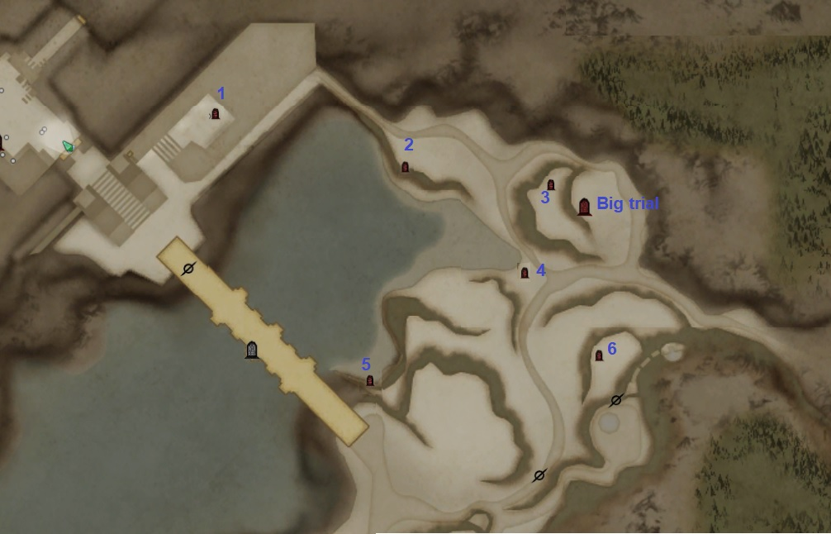

**Big trial Reward**:

Weekly first clear reward (random):

* Bone pearl.
* IR110 Leg clothing 4*.
* IR105 clothing 0-4*.
* Memento Fiber 100 pieces (Fixed).
* 13 Executor’s soul.
* 40 HO.

Repeatable reward:

* 6 Executor’s soul.
* 40 HO.
* ~~3 Memento Fiber (random).~~ Removed after 5/31

**Small trials reward**:

Free version:

* 21 Executor’s soul.
* 40 HO.
* 3 Memento Fiber (random).

Paid version:

* 1 Crest (random listed below, only listed highest tier it can drop).
* 80 HO.
* 3 Memento Fiber (Fixed).

**Monster:**

Harpy 8

Ancestor orc 14

Grimwarg 3

Direwolf 9

Grim goblin fighter 2

Captain Ancestor orc 1

Acid Blob 4

Grigori 2

Bearded Grigori 2

Foot Biter 6

Geo saurian 8

Giant Geo saurian 2

Mist hunter 2

Little crag 3

Mist Priest 1

Mist Fighter 3

Mist Sorcerer 2

#### Big Trial:

Condition: Do not die/ Inflict status debuffs 6 times/ Clear all mob.

Monster:

Ancestor origin 1

Fodden 1

Ancestor orc 10

#### Trial 1:

* Free version:

Condition: Time limit 4’/ Kill 4 mobs that have a status debuff active on them/ Clear all mob.

Monster:

Ancestor orc 8

Captain Ancestor orc 1

* Paid version:

Reward: Crest of Fragility ( Inflict Frail 20)

Crest of Dwindled Magick+ ( Inflict Magick atk down 30)

Crest of Frail Warding+ ( Resist Frail 25)

Crest of Lowered Magick Prevention ( Resist Magick atk down 25)

Condition: Time limit 4’30/ Kill 4 mobs that have a status debuff active on them/ Clear all mob.

Monster:

Ancestor Origin 1

Goblin Shaman 8

#### Trial 2:

* Free version:

Condition: Time limit 4’/ Kill 4 mobs that have a status debuff active on them/ Clear all mob.

Monster:

Ancestor orc 4

Greater goblin 8

* Paid version:

Reward: Crest of Beast Hunting IV ( Beast slayer 16)

Crest of Mutilation IV ( Winged slayer 16)

Crest of Dismantling IV ( Golem slayer 16)

Condition: Time limit 4’30/ Kill 4 mobs that have a status debuff active on them/ Clear all mob.

Monster:

Fodden 1

Goblin Aid shaman 6

#### Trial 3:

* Free version:

Condition: Do not take status debuff 3 times/ Do not use item/ Kill 20 mobs.

Monster:

Goblin aid shaman 1

Misery ghost 4

Aqua Jelly 4

Any monster killed will respawn shortly after.

* Paid version:

Reward: Crest of Deeper Sleep (Inflict Sleep 15)

Crest of Drowning (Inflict Drenching 20)

Crest of Sleep Warding (Resist Sleep 20)

Crest of Drench Warding (Resist Drenching 34)

Condition: Do not take status debuff 3 times/ Do not use item/ Kill 20 mobs.

Monster:

Medusa 1

Misery ghost 8

Any monster killed will respawn shortly after.

#### Trial 4:

* Free version:

Condition: Kill 4 mobs that have a status debuff active on them/ Do not die/ Clear all mob.

Monster:

Gorechimera 1

Grigori 8

* Paid version:

Reward: Crest of Freezing+ (Inflict Frozen solid 20)

Crest of Ice Warding+ (Ice resist 14)

Condition: Kill 4 mobs that have a status debuff active on them/ Do not die/ Clear all mob.

Monster:

Goremanticore 1

Bearded Grigori 8

#### Trial 5:

* Free version:

Condition: Time limit 2’/ Inflict Status debuffs 2 times/ Clear all mob.

Monster:

Captain Ancestor orc 1

Foot biter 8

* Paid version:

Reward: Crest of Diminished Lightning Resist (Inflict Thunder resist down 22)

Crest of Diminished Holy Resist (Inflict Holy resist down 22)

Crest of Shock Warding (Resist Shock 17)

Crest of Holy Drain Warding (Resist Holy Drain 25)

Crest of Decreased Thunder Resist Prevention (Resist Thunder Resist Down 34)

Crest of Decreased Holy Resist Prevention (Resist Holy Resist Down 34)

Condition: Time limit 2’30/ Inflict Status debuffs 2 times/ Clear all mob.

Monster:

Lindwurm 1

#### Trial 6:

* Free version:

Condition: Do not die/ Do not use item/ Clear all mob.

Monster:

Mist warrior 7

Mist hunter 1

* Paid version:

Reward: Crest of Blinding+ (Inflict Blind 26)

Crest of Dark Warding+ (Dark resist 14)

Condition: Do not die/ Do not use item/ Clear all mob.

Monster:

Mist warrior 7

Geo Golem 1

### Third section: Memory of Megadosys Highway (5/24) Monster lvl94/ Paid Trial cost 30 souls

### (Cost 198 souls to unlock, talk to NPC at the door pick last option to access 2nd section)

It will cost 120 souls to unlock each small trial in here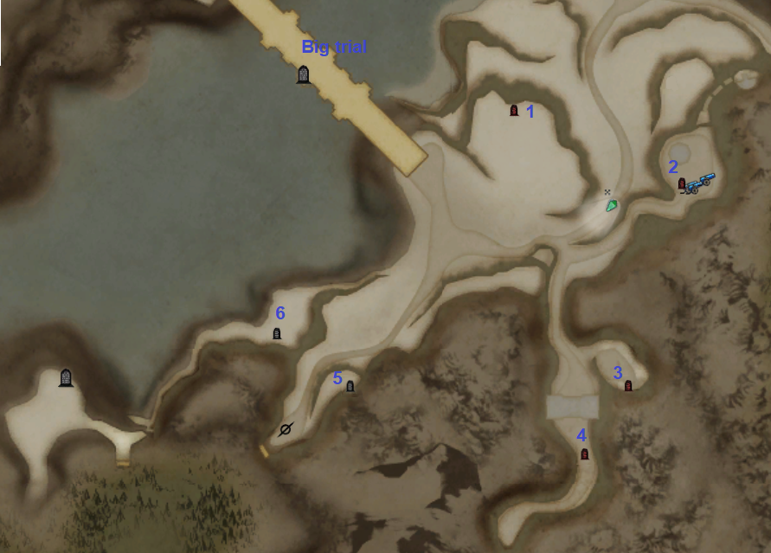

**Big trial Reward**:

Weekly first clear reward (random):

* Bone pearl.
* IR108 Weapons 4* Main hand( random)
* IR105 Weapon 4* Sub.
* IR110 Cloak 4*.
* IR105 clothing 0-4*.
* Relic steel 110 pieces (Fixed).
* 13 Executor’s soul.
* 40 HO.

Repeatable reward:

* 20 Executor’s soul.
* 40 HO.
* ~~3 Relic steel (random).~~ Removed after 5/31

**Small trials reward**:

Free version:

* 40 Executor’s soul.
* 40 HO.
* 3 Relic steel (random).

Paid version:

* 1 Crest (random listed below, only listed highest tier it can drop).
* 80 HO.
* 3 Relic steel (fixed).

**Monster:**

Skeleton warg 3

Shadow harpy 4

Shadow sling goblin 9

Shadow goblin fighter 4

Shadow goblin leader 8

Grudge ghost 2

Shadow wolf 3

Mist warrior 3

Mist priest 2

Eliminator 5

Flame Skeleton 2

Skeleton sorcerer 2

Mist sorcerer 1

#### Big Trial:

Condition: Time limit 5’/ Do not die/ Clear all mob.

Monster:

Death knight 5

#### Trial 1:

* Free version:

Condition: Time limit 5’/ Do not use item/ Clear all mob.

Monster:

Cragger 2

* Paid version:

Reward: Crest of Shock+ ( Inflict Shock 26)

Crest of Lightning Warding (Thunder Resist 14)

Condition: Time limit 5’/ Do not use item/ Clear all mob.

Monster:

Skeleton Cyclop 2

#### Trial 2:

* Free version:

Condition: Time limit 1’45/ Do not use item/ Kill 50 mobs.

Monster:

Wight 3

Rabbit 8

Note: any mobs killed will respawn shortly after.

* Paid version:

Reward: Crest of Fatal poison (Inflict poison 20)

Crest of Greater Tarring+ (Inflict tarring 20)

Crest of Poison Warding (Resist poison 25)

Crest of Tar Warding (Resist tarring 34)

Condition: Time limit 1’45/ Do not use item/ Kill 50 mobs.

Monster:

Empress ghost 3

Frog 8

Note: any mobs killed will respawn shortly after.

#### Trial 3:

* Free version:

Condition: Time limit 2’30/ Do not take status debuff 3 times/ Clear all mob.

Monster:

White chimera 1

Shadow goblin leader 2

* Paid version:

Reward: Crest of Demon slaying (Orge slayer 16)

Crest of Fracturing (Skeleton slayer 16)

Condition: Time limit 4’30/ Do not take status debuff 3 times/ Clear all mob.

Monster:

Shadow chimera 2

#### Trial 4:

* Free version:

Condition: Time limit 2’30/ Kill 20 mobs/ Do not use item.

Monster:

Death knight 1

Grudge ghost 5

Note: any mobs killed will respawn shortly after.

* Paid version:

Reward: Crest of Amplified attack (Blow power 15)

Crest of Greater Protection+ (Physical defense 7)

Condition: Time limit 3’30/ Kill 20 mobs/ Do not use item.

Monster:

Empress ghost 1

Bearded Grigori 5

Note: any mobs killed will respawn shortly after.

#### Trial 5:

* Free version:

Condition: Do not use item/ Do not die/ Clear all mob.

Monster:

Eliminator Slay 5

* Paid version:

Reward: Crest of Purification (Spirit Slayer 16)

Crest of Dragonsbane (Dragon slayer 16)

Condition: Do not use item/ Do not die/ Clear all mob.

Monster:

Empress ghost 1

Witch 1

Wight 1

#### Trial 6:

* Free version:

Condition: Do not die/ Do not take status debuffs 3 time/ Clear all mob.

Monster:

Witch 1

Skull lord 3

* Paid version:

Reward: Crest of Crystallization (Inflict Petrification 15)

Crest of Diminished Fire resist (Inflict Fire resist down 22)

Crest of Burn Warding (Resist catching fire 20)

Crest of Curse Warding (Resist Curse 15)

Crest of Petrification Warding (Resist Petrification 17)

Crest of Decreased Fire Resist Prevention (Resist Fire resist down 34)

Condition: Do not die/ Do not take status debuffs 3 time/ Clear all mob.

Monster:

Gigant machina 1

Frost machina 1

### Fourth section (5/31) Monster lvl95/ All paid trial cost 40 souls

### (Cost 297 souls to unlock, talk to NPC at the door pick last option to access 2nd section)

It will cost 240 souls to unlock each small trial in here

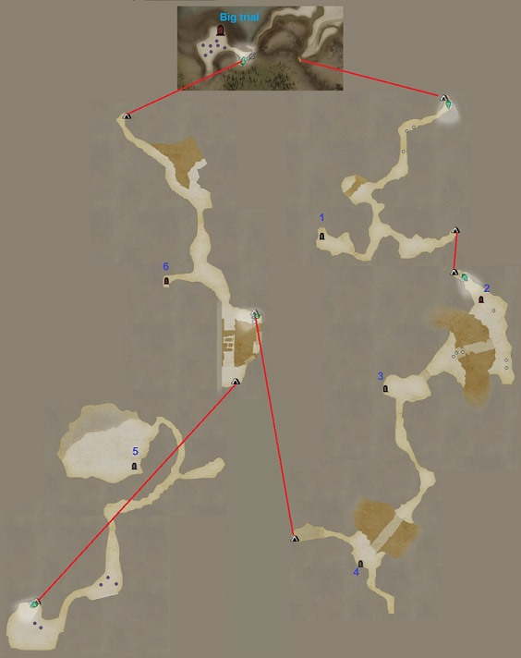

**Big trial Reward**:

Weekly first clear reward (random):

* Bone pearl.
* IR108 Weapons 4*( random)
* IR105 Weapon 4* Sub.
* IR110 Cloak 4*.
* IR105 clothing 0-4*.
* Relic steel 110 pieces (Fixed).
* Executor’s soul.
* 60 HO.

Repeatable reward:

* 6 Executor’s soul.
* 60 HO.
* ~~3 Memento Fiber (random).~~ Removed after 5/31

**Small trials reward**:

Free version:

* 80 Executor’s soul.
* 40 HO.
* 3 Relic steel (random).

Paid version:

* 1 Crest (random listed below, only listed highest tier it can drop).
* 80 HO.
* 3 Relic steel (fixed).

**Monster:**

Skeleton Knight 4

Frost Skeleton 4

Skeleton Mage 2

Frost Skeleton Brute 1

Skeleton warg 5

Skeleton sorcerer 3

Bolt Grimwarg 1

Little Crag 5

Ancestor orc 2

Captain ancestor orc 2

Goblin shaman 2

Grimwarg 2

Mist hunter 3

Mist warrior 2

Mist Fighter 4

Mist sorcerer 2

Heavy Soldier dwarf orc 2

Sword Soldier dwarf orc 6

Ranged Soldier dwarf orc 3

Random War ready type 1

#### Big Trial:

Condition: Do not die/ Do not take debuffs 3 time/ Clear all mob.

Monster:

War-ready Goremanticore 1

War-ready Nightmare 1

#### Trial 1:

* Free version:

Condition: Do not die/ Do not take debuffs 3 time/ Clear all mob.

Monster:

Flame Skeleton brute 3

Skull lord 2

* Paid version:

Reward: Crest of Diminished Ice Resist (Inflict Ice resist down 22)

Crest of Diminished Dark Resist (Inflict Dark resist down 22)

Crest of Freeze Warding+ (Resist Frozen solid 20)

Crest of Blind Warding+ (Resist Blind 17)

Crest of Decreased Ice Resist Prevention (Resist Ice resist down 34)

Crest of Decreased Dark Resist Prevention (Resist Dark resist down 34)

Condition: Do not die/ Do not take debuffs 3 time/ Clear all mob.

Monster:

Living Armor 2

Skull lord 3

#### Trial 2:

* Free version:

Condition: Do not use item/ Do not die/ Clear all mob.

Monster:

Skeleton warg 8

Medusa 2

* Paid version:

Reward: Crest of Unburdening (For weapon Weight -15%)

Crest of Greater Magick+ (Magick attack 9)

Crest of Unburdening (For Armor Weight -20%)

Condition: Do not die/ Do not take debuffs 3 time/ Clear all mob.

Monster:

Witch 2

Bolt Grimwarg 8

#### Trial 3:

* Free version:

Condition: Time limit 3’/ Do not use item/ Clear all mob.

Monster:

Fodden 1

* Paid version:

Reward: Crest of Greater Power+ (Physical Attack 9)

Crest of Stubborn Perseverance+ (Endurance 12)

Condition: Time limit 3’/ Do not use item/ Clear all mob.

Monster:

Gorecyclop 1

#### Trial 4:

* Free version:

Condition: Time limit 3’30/ Do not use item/ Clear all mob

Monster:

Ghoul 2

* Paid version:

Reward: Crest of Giant Killing IV (Giant Slayer 16)

Crest of Expulsion IV (Demon Slayer 16)

Condition: Time limit 4’30/ Do not use item/ Clear all mob

Monster:

Spineback 2

#### Trial 5:

* Free version:

Condition: Do not die/ Do not take debuffs 3 time/ Clear all mob.

Monster:

Gorechimera 1

White chimera 1

* Paid version:

Reward: Crest of Massacre IV (Undead Slayer 16)

Crest of Splicing IV (Formless Slayer 16)

Condition: Do not die/ Do not take debuffs 3 time/ Clear all mob.

Monster:

White Griffin 1

Black Griffin 1

#### Trial 6:

* Free version:

Condition: Time limit 3’30/ Do not use item/ Clear all mob.

Monster:

Ent 2

Goblin Aid Shaman 3

* Paid version:

Reward: Crest of Dazzling (Knockout power 5)

Crest of Glittering Gold (Inflict Golden 15)

Crest of Dwindled Magick Defense+ (Inflict Magick def down 30)

Crest of Stunning Warding+ (Resist Knockout 25)

Crest of Golden Warding+ (Resist Golden 17)

Crest of Lowered Magick Prevention (Resist Magick def down 25)

Condition: Time limit 3’30/ Do not use item/ Clear all mob.

Monster:

Ancestor origin 2

Ancestor orc 3

### Final Trial ( Evil eye) First clear every week will drop material to upgrade King’s gear set (reset at 5am Monday JST)

So its best to start farming it right now

Weekly first clear reward:

* 6 King Draf Enthronement Commemerotive Coins.

Repeatable reward:

* 80 Executor’s soul.
* 80 HO.

Condition: Do not die/ Do not take debuffs 3 time/ Kill evil eye.

Monster:

Evil eye 1

Skeleton cyclop 2

Tentacle xxx

Note: have fog phase, cyclop do not respawn, Eye and 2 cyclops each give 15 PP.

# Season 3.3: Memory of Ulteca

Release date: 2018/9/06. IR require: 112

### First section (9/6) All monster Lvl98 Each small trial cost 20 souls to unlock

**Big trial Reward**:

Weekly first clear reward (random):

* Bone pearl.
* IR120 Body clothing 4*.
* IR115 clothing 0-4*.
* Memento Fiber(Urteca District) 100 pieces (Fixed).
* 13 Retainer’s Spirit.
* 40 HO.

Repeatable reward:

* 6 Retainer’s Spirit.
* 40 HO.

**Small trials reward**:

Free version:

* 10 Retainer’s Spirit.
* 40 HO.
* 3 Memento Fiber(Urteca District) (random).

Paid version:

* 1 Crest (random listed below, only listed highest tier it can drop).
* 80 HO.
* 3 Memento Fiber(Urteca District) (Fixed).

**Monster:**

Tentacle 21

Hellhound 3

Killer bee 13

Grigori 3

Bearded Grigori 1

Blaze goblin leader 2

Blaze goblin 6

Giant Geo saurian 2

Geo saurian 5

#### Big Trial:

Condition: Kill Eye/ Do not take debuff 3 time/ Do not die

Monster:

Volt Eye 1

Tentacle 4

#### Trial 1:

* Free version:

Condition: Do not use item/ Do not take debuff 3 times

Monster:

Grigori 5

Sphinx 1

* Paid version:

Reward: Crest of Holy Drain + (Inflict Holy drain 26)

Crest of Holy Warding+ (Holy resist 14)

Condition: Do not use item/ Do not take debuff 3 times

Monster:

Nightmare 1

Bearded Grigori 4

#### Trial 2:

* Free version:

Condition: Time limit 3’/ Do not take debuff 3 times

Monster:

Manticore

* Paid version:

Reward: Crest of Torpor (Inflict Torpor 10)

Crest of Torpor Warding+ ( Resist Torpor 20)

Crest of Dwindled Strength + ( Inflict Physical Atk Down 30)

Crest of Lowered Strength Prevention ( Resist Physical Atk Down 25)

Condition: Time limit 4’/ Do not take debuff 3 times

Monster:

Goremanticore

#### Trial 3:

* Free version:

Condition: Time limit 3’/ Do not die/ Kill colossus

Monster:

Colossus 1

Killer Bee 9 ( will keep respawn)

* Paid version:

Reward: Crest of Sealing+ (Inflict Skill Stifling 20)

Crest of Dwindled Defense+ ( Inflict Physical def down 30)

Crest of Stifle Warding+ ( Resist Skill Stifling 20)

Crest of Lowered Defense Prevention (Resist Physical Def down 25)

Condition: Time limit 4’/ Do not die/ Kill drake

Monster:

Drake 1

Killer Bee 9 ( will keep respawn)

#### Trial 4:

* Free version:

Condition: Kill 5 tentacle/ Time limit 5’/ Do not take debuff 3 times

Monster:

Tentacle 10

* Paid version:

Reward: Crest of Flesh Cutting IV (Demihuman Slayer 16)

Crest of Manslaying IV ( Human Slayer 16)

Condition: Kill 5 Vile eye/ Time limit 5’/ Do not take debuff 3 times

Monster:

Vile Eye 10

#### Trial 5:

* Free version:

Condition: No item/ Do not die

Monster:

Blaze Gregori 5

* Paid version:

Reward: Crest of Greater Intelligence+ (Magick Defense 7)

Crest of Fortitude + (Healing Power 7)

Condition: No item/ Do not die

Monster:

Blazechimera 1

#### Trial 6:

* Free version:

Condition: No item/ Do not die

Monster:

Burnt Ent 1

Hellhound 4

* Paid version:

Reward: Crest of Burning+ (Inflict Catching Fire 26)

Crest of Flame Warding+ (Fire Resist 14)

Condition: No item/ Do not die

Monster:

Burnt Ent 1

Gorechimera 1

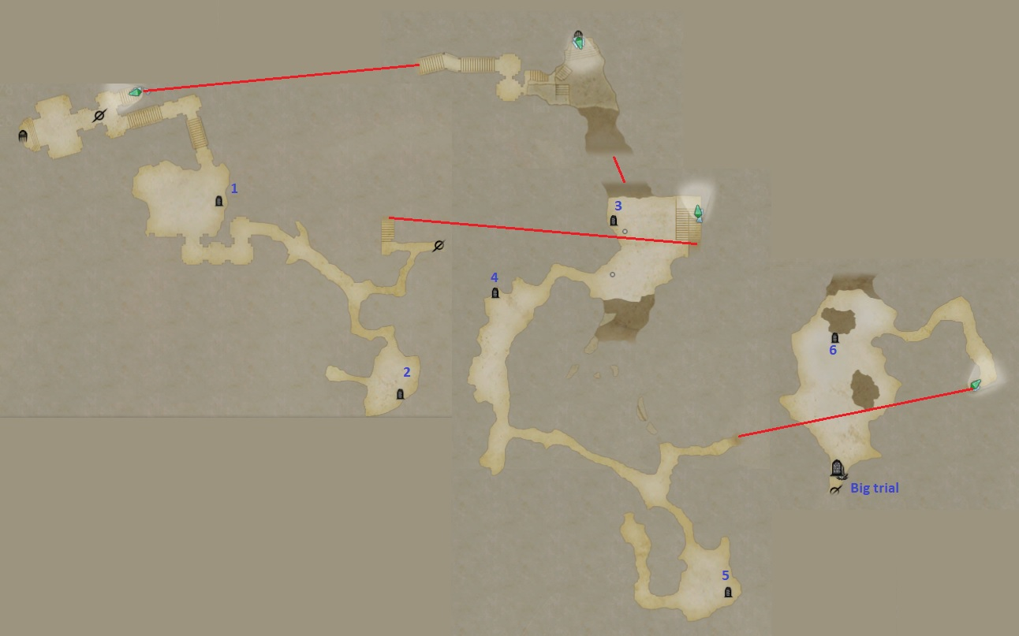

### Second Section (9/13) Require 99 Spirits to unlock, talk to NPC at door, pick last option

**~~Some Paid Trial is currently bugged on PC, will freeze the game if you attempt to active it~~ Fixed at 9/14 emergency maintenance**

Each small trials need 60 Spirits to unlock

**Big trial Reward**:

Weekly first clear reward (random):

* Bone pearl.
* IR120 Leg wear 4*.
* IR115 clothing 0-4*.
* Memento Fiber(Urteca District) 100 pieces (Fixed).
* 13 Retainer’s Spirit.
* 40 HO.

Repeatable reward:

* 6 Retainer’s Spirit.
* 40 HO.

**Small trials reward**:

Free version:

* 10 Retainer’s Spirit.
* 40 HO.
* 3 Memento Fiber(Urteca District) (random).

Paid version:

* 1 Crest (random listed below, only listed highest tier it can drop).
* 80 HO.
* 3 Memento Fiber(Urteca District) (Fixed).

**Monster:**

Blaze Harpy 3

Megado Guard 20

Grimwarg 5

Hell hound 3

Ghost Mail 2

Skeleton warg 4

Geo Saurian 2

Giant Geo Saurian 1

Saurian Sage 1

Greater Goblin 3

Ancestor orc 4

Captain Ancestor orc 2

#### Big Trial:

Condition: Time limit 7’/ Do not die/ Kill all mob

Monster:

Grand Ent 1

Ent 2

#### Trial 1:

* Free version:

Condition: Time limit 4’/ Do not use item

Monster:

Death Knight 1

Eliminator Slay 4

* Paid version:

Reward:

Crest of Fragility (Inflict Frail 20)

Crest of Dwindled Magick+ (Inflict Magick Atk Down 30)

Crest of Frail Warding+ (Resist Frail 25)  
 Crest of Lowered Magick Prevention (Resist Magick Atk Down 25)

Condition:

Monster:

#### Trial 2:

* Free version:

Condition: Time limit 3’/ Do not die

Monster:

Captain Ancestor Orc 2

Ancestor Orc 8

* Paid version:

Reward: Crest of Deeper Sleep (Inflict Sleep 15)

Crest of Drowning (Inflict Drenching 20)

Crest of Sleep Warding+ (Resist Sleep 20)

Crest of Drench Warding (Resist Drenching 34)

Condition:

Monster:

#### Trial 3:

* Free version:

Condition: Do not use item/ Do not die/ Kill all mob

Monster:

Behemoth 1

Megado Guard 6

* Paid version:

Reward: Crest of Freezing+ (Inflict Frozen solid 20)

Crest of Ice Warding+ (Ice Resist 14)

Condition:

Monster:

#### Trial 4:

* Free version:

Condition: Time limit 3’/ Do not take debuff 3 times

Monster:

Living Armor 4

* Paid version:

Reward: Crest of Beast Hunting IV (Beast Slayer 16)

Crest of Mutilation IV (Winged Slayer 16)

Crest of Dismantling IV (Golem Slayer 16)

Condition:

Monster:

#### Trial 5:

* Free version:

Condition: Do not die/ Inflict debuff 2 times

Monster:

Skeleton Cyclop 1

Megado Guard 6

* Paid version:

Reward: Crest of Blinding+ (Inflict Blind 26)

Crest of Dark Warding+ (Dark Resist 14)

Condition:

Monster:

#### Trial 6:

* Free version:

Condition: Do not use item/ Do not take debuff 3 times/ Kill 20 mobs

Monster:

Giant Saurian Sage 1

Saurian Sage 6

* Paid version:

Reward: Crest of Diminished Lightning Resist (Inflict Thunder resist down 22)

Crest of Diminished Holy Resist (Inflict Holy resist down 22)

Crest of Shock Warding+ (Resist Shock 17)

Crest of Holy Drain Warding+ (Resist Holy drain 25)

Crest of Decreased Thunder Resist Prevention (Resist thunder resist down 34)

Crest of Decreased Holy Resist Prevention (Resist Holy resist down 34)

Condition:

Monster:

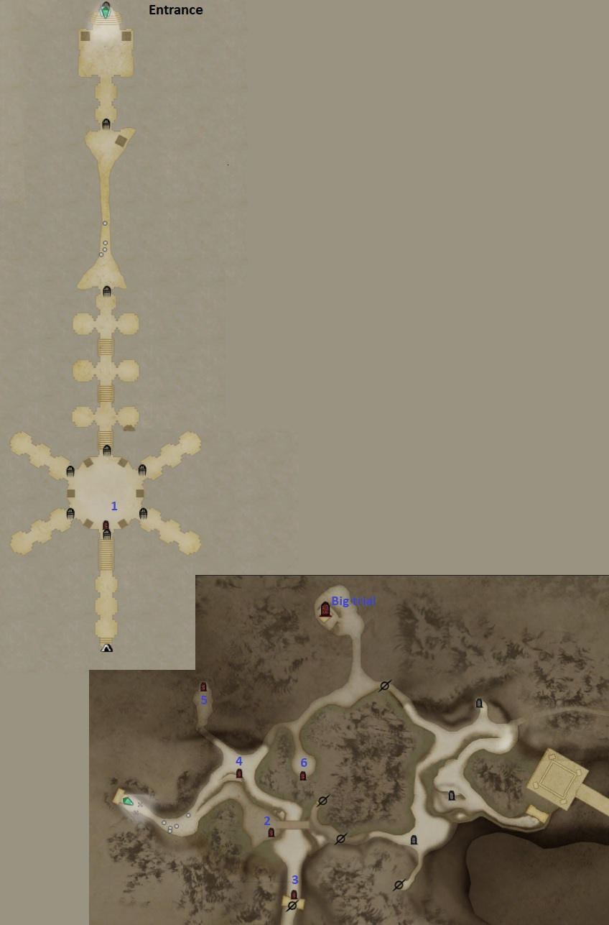

### Third Section (9/20) Cost 198 Spirits to unlock

Each small trials need 120 Spirits to unlock

**Big trial Reward**:

Weekly first clear reward (random):

* Bone pearl.
* IR118 Weapon
* IR115 Sub Weapon ( Highest drop rate)
* IR120 Cloak 4*.
* IR115 clothing 0-4*.
* Relic Steel (Urteca District) 100 pieces (Fixed).
* 13 Retainer’s Spirit.
* 40 HO.

Repeatable reward:

* 6 Retainer’s Spirit.
* 40 HO.

**Small trials reward**:

Free version:

* 40 Retainer’s Spirit.
* 40 HO.
* 3 Relic Steel (Urteca District) (random).

Paid version:

* 1 Crest (random listed below, only listed highest tier it can drop).
* 80 HO.
* 3 Relic Steel (Urteca District) (Fixed).

**Monster:**

Blaze Goblin 10

Pyre Saurian 3

Blaze Goblin Leader 6

Blaze Wolf 6

Blaze Grigori 4

Pyro Slime 3

Greater Goblin 2

Shadow Goblin Leader 10

Shadow Sling goblin 6

#### Big Trial:

Condition: Do not die/Do not take debuff 3 times/ Kill the dragon

Monster:

Elder Dragon (Normal) 1

#### Trial 1:

* Free version:

Condition: Time limit 4’/ Kill 20 mobs/ Do not take debuff 3 times

Monster:

Pyre Saurian 5

Blaze Goblin 5

Notes: any mobs killed will respawn shortly after.

* Paid version:

Reward: Crest of Fatal Poison (Inflict Poison 20)

Crest of Greater Tarring (Inflict Tarring 20)

Crest of Poison Warding+ (Resist Poison 25)

Crest of Tar Warding+ (Resist Tarring 34)

Condition:

Monster:

#### Trial 2:

* Free version:

Condition: Do not die/ Kill 20 mobs/ Do not take debuff 3 times

Monster:

Geo Golem 1

Blaze Harpy 6

Notes: any mobs killed will respawn shortly after.

* Paid version:

Reward: Crest of Amplified Attack (Blow power 15)

Crest of Greater Protection+ (Physical defense 7)

Condition:

Monster:

#### Trial 3:

* Free version:

Condition: Time limit 4’/ Clear all mob/ Do not take debuff 3 times

Monster:

Gorechimera 1

Blaze Goblin 4

* Paid version:

Reward: Crest of Demon Slaying IV (Ogre Slayer 16)

Crest of Fracturing IV (Skeleton Slayer 16)

Condition:

Monster:

#### Trial 4:

* Free version:

Condition: Do not use item/ Do not take debuff 5 times/ Clear all mob

Monster:

Shadow Chimera 1

Shadow Goblin Leader 3

Blaze Grigori 3

* Paid version:

Reward: Crest of Shock+ (Inflict Shock 26)

Crest of Lightning Warding+ (Thunder resist 14)

Condition:

Monster:

#### Trial 5:

* Free version:

Condition: Do not use item/ Time limit 3’30/ Clear all mob

Monster:

Skeleton Lord 2

Blaze Grigori 3

* Paid version:

Reward: Crest of Crystallization (Inflict Petrification 15)

Crest of Diminished Fire Resist (Inflict Fire resist down 22)

Crest of Burn Warding + (Resist Catching fire 20)

Crest of Curse Warding+ (Resist Curse 15)

Crest of Petrification Warding+ (Resist Petrification 17)

Crest of Decreased Fire Resist Prevention (Resist Fire Resist Down 34)

Condition:

Monster:

#### Trial 6:

* Free version:

Condition: Kill 10 mobs/ Do not die/ Do not take debuff 3 times

Monster:

Skeleton Lord 1

Tentacle 6

Notes: any mobs killed will respawn shortly after.

* Paid version:

Reward: Crest of Purification IV (Spirit Slayer 16)

Crest of Dragonsbane IV (Dragon Slayer 16)

Condition:

Monster:

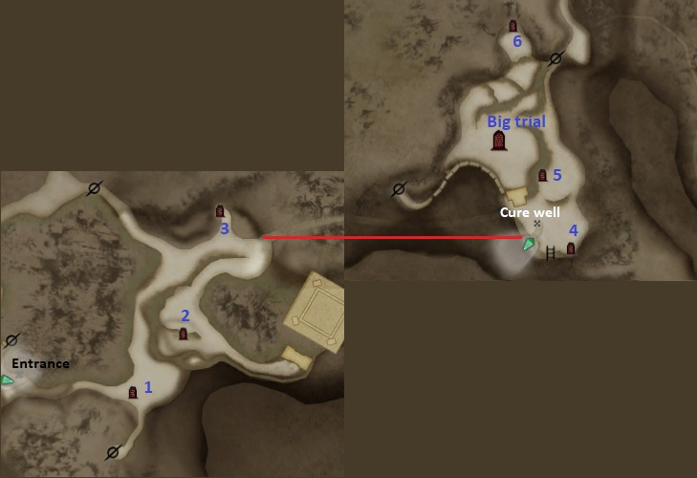

### Fourth Section (9/27) 297 Spirits to unlock All monster lvl100

240 Spirits to unlock each small trial

**Big trial Reward**:

Weekly first clear reward (random):

* Bone pearl.
* IR118 Weapon 4*
* IR115 Sub Weapon ( Highest drop rate)
* IR120 Cloak 4*.
* IR115 clothing 0-4*.
* Relic Steel (Urteca District) 100 pieces (Fixed).
* 13 Retainer’s Spirit.
* 40 HO.

Repeatable reward:

* 6 Retainer’s Spirit.
* 40 HO.

**Small trials reward**:

Free version:

* 80 Retainer’s Spirit.
* 40 HO.
* 3 Relic Steel (Urteca District) (random).

Paid version:

* 1 Crest (random listed below, only listed highest tier it can drop).
* 80 HO.
* 3 Relic Steel (Urteca District) (Fixed).

**Monster:**

Greater Goblin 3

Ranged Soldier Dwarf Orc 8

Heavy Soldier Dwarf Orc 8

Pyre Saurian 1

Blaze Goblin 4

Blunt Soldier Dwarf Orc 2

Blaze Harpy 4

Blaze Grigori 3

Skeleton Warg 2

Skull Lord 1

Blaze Wolf 4

War-Ready Grimwarg 3

Tentacle 3

Eliminator Slay 1

#### Big Trial:

Condition: Do not die/ Do not take debuffs 3 times/ Kill Ifrit.

Monster:

Ifrit 1

#### Trial 1:

* Free version:

Condition: No item/ Time limit 4’

Monster:

Black Griffin 1

* Paid version:

Reward: Crest of Greater Power+ (Physical attack 9)

Crest of Stubborn Perseverance+ (Endurance 12)

Condition: No item/Time limit 5’

Monster:

War-Ready Nightmare 1

#### Trial 2:

* Free version:

Condition: Do not die/Time limit 4’/ Kill 10 enemies

Monster:

Cragger 1

Ranged Soldier Dwarf Orc 6

Note: any mob slain will respawn shortly after.

* Paid version:

Reward: Crest of Giant Killing IV (Giant Slayer 16)

Crest of Expulsion IV (Demon Slayer 16)

Condition:

Monster:

#### Trial 3:

* Free version:

Condition: Destroy all armor part/ Inflict debuff 2 time

Monster:

War-Ready Ogre 1

* Paid version:

Reward: Crest of Dazzling (Knockout Power 5)

Crest of Glittering Gold (Inflict Golden 15)

Crest of Dwindled Magick Defense+ (Inflict Magick Def. Down 30)

Crest of Stunning Warding+ (Resist Knockout 25)

Crest of Golden Warding+ (Resist Golden 17)

Crest of Lowered Magick Prevention (Resist Magick Def. Down 25)

Condition:

Monster:

#### Trial 4:

* Free version:

Condition: Do not die/ Do not take debuffs 3 times

Monster:

Medusa 1

Blaze Grigori 4

* Paid version:

Reward: Crest of Unburdening ( Weight -15% Weapon)

Crest of Greater Magick+ (Magick attack 9)

Crest of Unburdening ( Weight -20% Armor)

Condition:

Monster:

#### Trial 5:

* Free version:

Condition: No item/ Do not die/ Kill 10 mobs

Monster:

Empress Ghost 1

Heavy Soldier Dwarf Orc 5

Note: Any mobs slain will respawn shortly after.

* Paid version:

Reward: Crest of Diminished Ice Resist (Inflict Ice Resist Down 22)

Crest of Diminished Dark Resist (Inflict Dark Resist Down 22)

Crest of Freeze Warding+ ( Resist Frozen Solid 20)

Crest of Blind Warding+ (Resist Blind 17)

Crest of Decreased Ice Resist Prevention (Resist Ice Resist Down 34)

Crest of Decreased Dark Resist Prevention (Resist Dark Resist Down 34)

Condition:

Monster:

#### Trial 6:

* Free version:

Condition: Do not die/ Do not take debuff 3 times/ Kill Drake

Monster:

Drake 1

Blaze Harpy 6

* Paid version:

Reward: Crest of Massacre IV ( Undead Slayer 16)

Crest of Splicing IV ( Formless Slayer 16)

Condition: Do not die/ Do not take debuff 3 times/ Kill Zuhl

Monster:

Zuhl 1

Blaze Harpy 6

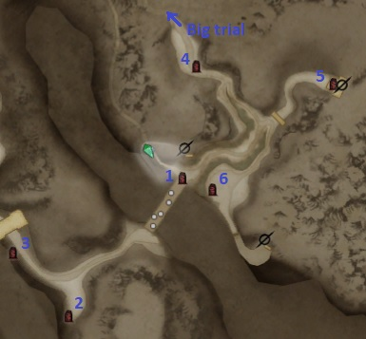

### Final Trial : Ghost of the First King First clear every week will drop material to upgrade King’s gear set (reset at 5am Monday JST)

**The actual King Gear Upgrade will be implement at a later date**

So its best to start farming it right now

Weekly first clear reward:

* 6 King Kileek Enthronement Commemerotive Coins.

Repeatable reward:

* 80 Retainer’s Spirit.
* 80 HO.

Condition: Do not die/ Kill Ghost of the First King.

Monster:

Ghost of the First King 1

Megado Guard 4

Note: All Human type mob, easily cheese with skill that generate wind/tremor or restrict movement (Shield Sage anchor), can be grab-hold.